Katherine A. Kendall Institute for International Social Work Education
Request for Grant Proposals

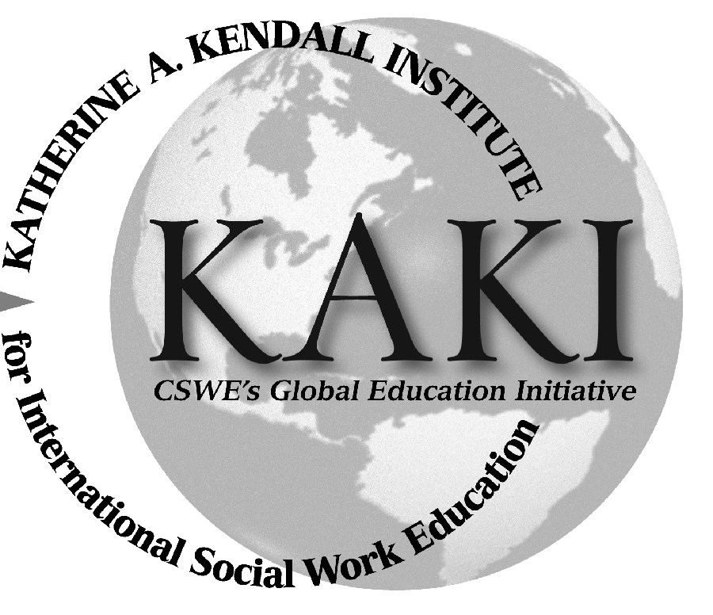

Dear Applicant,

The Katherine A. Kendall Institute for International Social Work Education (KAKI) strives to prepare educators, researchers, students, and practitioners for an increasingly global community through its programs and initiatives. Established in 2004 with contributions to an endowment in honor of the late international social work icon Dr. Katherine A. Kendall, KAKI promotes standards of excellence for international social work to integrate related concepts into social work curricula and seeks to enrich perspectives, understandings, collaboration, and networking within the social work community.

KAKI is pleased to offer up to three international social work grant opportunities to CSWE members at a maximum of $10,000 for the CSWE fiscal year 2015–2016. KAKI hopes to fund curriculum-building projects that support education in international social work and enhance curriculum building that focuses on international and/or global topics. The projects should help prepare North American students for global citizenship and encourage opportunities for international social work. The grant topics should strengthen what Americans know about the world and should be U.S. based. Opportunities can also include work with nongovernmental organizations, the United Nations, or other international entities.

This grant is open to all CSWE members; one member of the project team must be a CSWE member throughout the duration of the grant. Travel funding should not be the primary purpose of the grant application. Depending on the nature of the project, a progress report may be required. Projects should be completed within 3 years. Project participants must be affiliated with an organization that strengthens social work education. No overhead costs will be permitted.

Proposals will be accepted by e-mail only at kaki@cswe.org through August 31, 2015. The proposal should be no more than 10 pages. If you are interested in applying for funding, please complete the following grant application.

Thank you for your interest in the Katherine A. Kendall Institute.

Sincerely,

The Katherine A. Kendall Institute Advisory Board

Grant Application Contents

- Cover Page

- Project Abstract

- Statement of Need

- Project Description

- Goals and Objectives

- Timeline

- Budget

Proposal Contents

- Cover Letter
Please provide a brief cover letter, no more than one page, that includes the name of the project you are requesting funding for and the name(s) and contact information of the project participants(s) and/or staff member(s) involved in the project. Also include the host organization for the project team.

- Project Abstract
The abstract should present a concise summary of the project. It should include the need for the project, the population it will serve, and its goals and objectives, as well as the applicant’s background and qualifications. Make sure you include the amount of funding that is being sought. Finally, mention how the project will be evaluated to measure its success.

- Statement of Need
The statement of need should describe the problem the project will attempt to address. Also, describe the population that will be served.

- Project Description
Describe the project and provide information on how it will be implemented. Include information on what will be accomplished and the desired outcome.

- Goals and Objectives
Describe the project objectives in expected/specific outcomes.

- Timeline
Please provide a timeline for the project. Also include when the project funds will used.

- Budget
Include in the budget all expenses for your project. Please mention any funding that you are using from other sources.

