Generalist Social Work Practice: International and Global Perspectives
Teaching Module Prepared for BSW and MSW Generalist Social Work Practice Courses
Carol S. Cohen, Adelphi University
Overview of This Module and Contents
This module focuses on the integration of international content in generalist social work practice courses in the BSW and MSW foundation curricula and consists of this guide and PowerPoint slides. This guide includes the text of the PowerPoint slides and some elaboration of the content. It is part of an overall initiative of the CSWE Council on Global Learning, Research, and Practice to assist faculty members in their efforts to internationalize the social work curriculum.
In constructing the PowerPoint and guide, we recognize that faculty members will adapt and selectively choose slides and content that relates to the timing, structure, and content of their Generalist Practice courses. Faculty members using this module are encouraged to adapt it to meet their own needs and are free to use selected slides and one or more of the suggested teaching strategies. We ask that faculty members cite the material from this module and contribute suggestions about how the guide could be enriched and expanded.
Many of the slides are densely filled with information – faculty members may find that this material is better used as a handout or, in some cases, may find it more useful to open the original documents through the links provided (such as CSWE Educational Policy and Accreditation Standards [EPAS]) or organizational websites (such as those of the National Association of Social Workers [NASW] and the International Association of Schools of Social Work [IASSW].
PowerPoint Slide 2: The Contents of the Guide
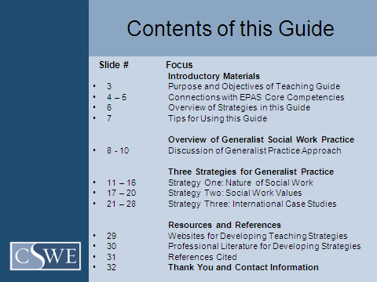
Introductory Materials
These slides are meant for faculty members rather than students. They explain the rationale for the module and its connection with accreditation standards. In addition, this section includes a quick review of the three teaching strategies and the resources that are included in the guide.
Slide 3 begins with a clear statement of purpose for this module in relation to teaching generalist social work practices and includes accompanying objectives for students and faculty.

PowerPoint Slide 3: Purpose and Objectives of Teaching Guide
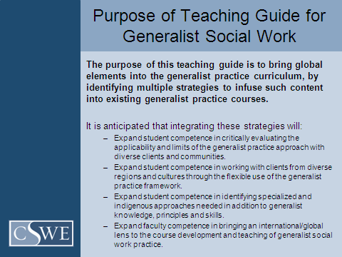
Slides 4 and 5 focus on the connection of this module with the EPAS Core Competencies as outlined in Educational Policy 2.1.10(a)–(d) and the other Core Competencies that intersect with generalist practice. EPAS is available at: http://www.cswe.org/File.aspx?id=13780 and provided as a hot link in the PowerPoint.
PowerPoint Slides 4 and 5: Connections With EPAS Core Competencies
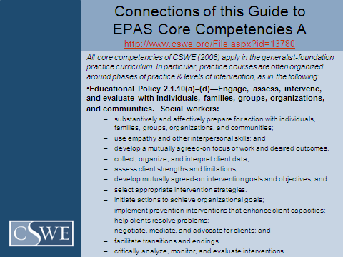
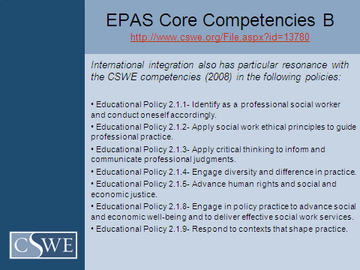
Slide 6 provides an overview of the three proposed teaching strategies and the resources that follow these strategies. Slide 7 focuses on tips for faculty members in using the teaching strategies in generalist social work practice courses and the resources that are available. The websites and literature cited may be useful for reading assignments to accompany these strategies.
PowerPoint Slide 6: Teaching Strategies and Resources Featured in This Guide
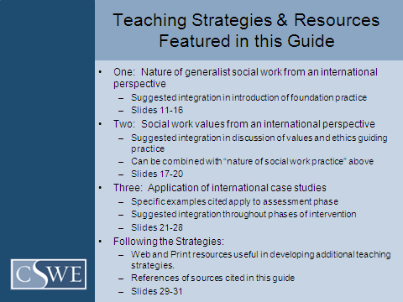
PowerPoint Slide 7: Tips for Faculty Using the Featured Teaching Strategies
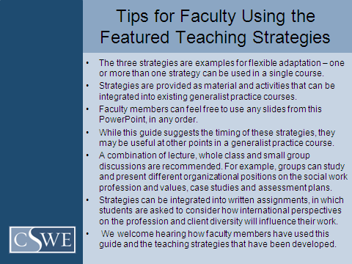
Discussion of the Generalist Practice Approach (Slides 8–10)
These slides can be used by faculty members alone or in classes with students, as adjunct materials to what is already discussed in texts and in the classroom.
Descriptions of generalist practice appear in most textbooks used in foundation practice classes. This section includes the CSWE Educational Policy regarding generalist practice, discussion of its features, and notes challenges in looking at practice in an international context. The purpose of this section is to provide context for the teaching strategies. Slide 8 provides CSWE’s definition of generalist social work practice.
Slide 9 includes a synthesis of key features of the generalist social work practice approach developed by Carol S. Cohen of the Adelphi University School of Social Work. Slide 10 provides a summary of the challenges documented in many previous efforts to internationalize social work practice and cites contemporary literature for further reading.
A reviewer of this module suggested that the points in Slide 10, about the concerns around globalization (universalism, imperialism, and indigenization) can introduce a rich conversation with students. This might be an appropriate introductory topic for student blogging.
PowerPoint Slide 8: Generalist Social Work Practice: Introduction
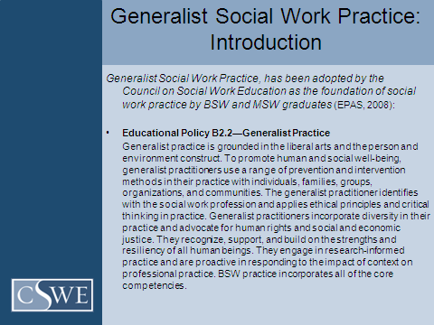

PowerPoint Slide 9: Features of the Generalist Social Work Practice Approach
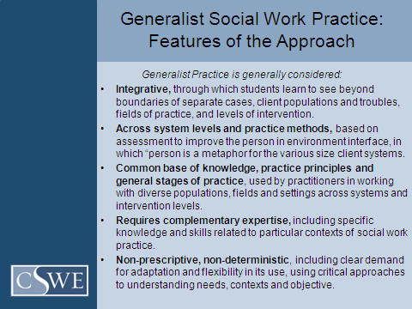

PowerPoint Slide 10: Challenges to Internationalizing Generalist Social Work Practice
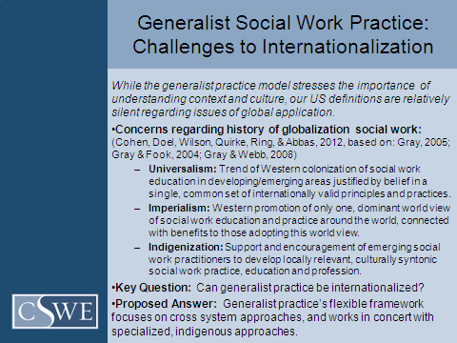

Strategy 1: Nature of Social Work (Slides 11–15)
This strategy can be used in concert with the following one on social work values. It begins with an introduction to this strategy, including a frame for looking at organizational statements about the profession, and includes questions that may be useful in teaching in the classroom and in assignments. Next is a slide with the CSWE description of the social work profession, followed by statements from NASW and IFSW/IASSW, which also describe/define the profession. We have also included a slide describing the IFSW statement on the nature of social development, allied with the previous statements on social work practice and the profession.
Students can engage in comparing and contrasting the statements and considering their individual and collective implications for the nature of social work practice and the students’ work with clients and communities. The websites cited in the PowerPoint are hot links to the documents. In addition to providing the complete documents, the organizational websites (provided in the resources section) provide links to background material on how these statements were constructed. The IFSW website (www.ifsw.org) provides a very useful map for connecting to organizations of social workers all over the world (http://ifsw.org/membership/worldview/). At the related site (http://voicesofsocialwork.org/) students can read international stories of why people became social workers.
PowerPoint Slide 11: Strategy 1 Introduction
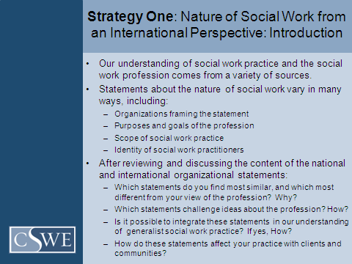

PowerPoint Slide 12: CSWE Statement
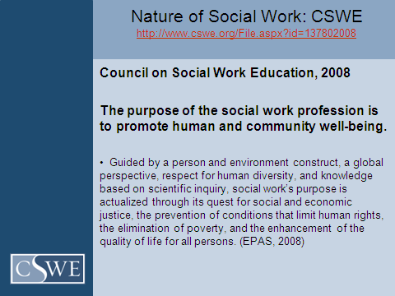
PowerPoint Slide 13: NASW Statement
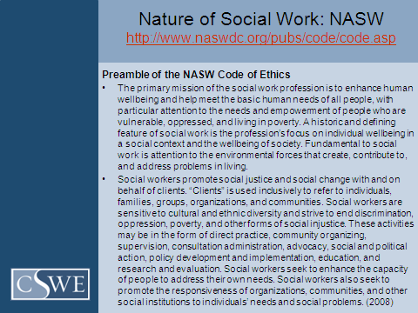

PowerPoint Slide 14: IFSW/IASSW Definition of Social Work Statement
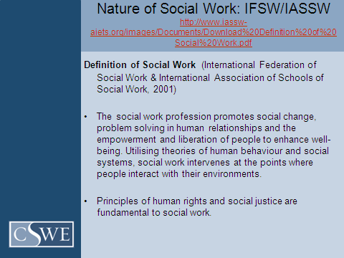
PowerPoint Slide 15: IFSW/IASSW Definition of Social Work Practice
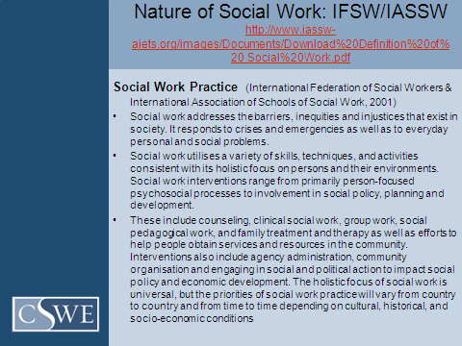

PowerPoint Slide 16: International Council on Social Welfare ( ICSW) Organizational Objectives of Social Development
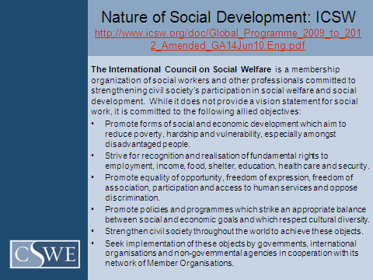
Strategy 2: Social Work Values (Slides 17–19)
This strategy follows a similar format to the previous one on the nature of social work. These two strategies can be used in concert, depending on how the course is constructed. The slide begins with an introduction to using the strategy and questions that can be used in teaching in the classroom or as part of assignments.
Strategy 2 then provides the CSWE description of social work values, followed by statements from NASW and IFSW/IASSW. All websites cited in this section are hot links to the full documents. Although each statement of values covers some similar areas, there are key differences in language and emphasis. By examining the statements, students can consider what it means to have an international orientation to social work values and how these values influence practice in the field.

PowerPoint Slide 17: Introduction to Social Work Values in an International Perspective
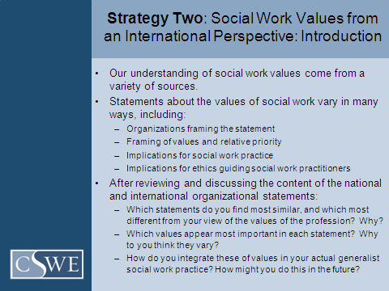
PowerPoint Slide 18: CSWE Statement of Social Work Values
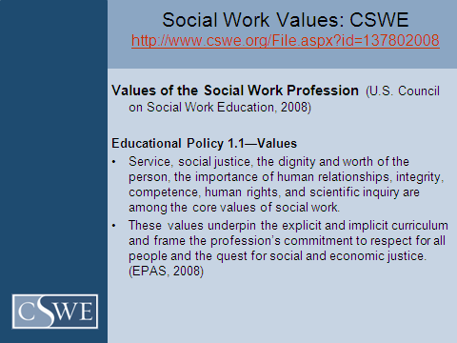

PowerPoint Slide 19: NASW Statement of Social Work Values
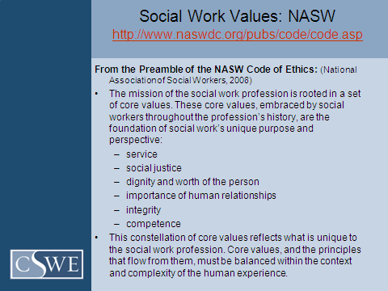
Slide 20: IFSW/IASSW Statement on Social Work Values
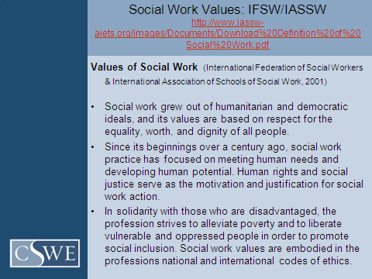

Strategy 3: International Case Studies (Slides 21–28)
This section of the guide begins with an overview of Strategy 3, including objectives for student learning and sample questions that can be posed to students in class and/or in assignments. It is based on using the two case studies presented and encourages faculty to incorporate these examples when they discuss using assessment tools with clients in the field.
This strategy highlights two assessment tools that are commonly used in generalist social work practice. Genograms and ecomaps are described briefly, and citations/references can be used as assigned readings about employing these tools when texts and other course readings do not have this material. Two case studies are presented. Each includes a brief summary followed by genograms and ecomaps illustrating the family situation.
The first case study (the Ba family) was developed in Vietnam by a group of faculty members at Open University in Ho Chi Min City. Faculty members may be interested in the background of this curriculum development project discussed in the article by Forgey, Cohen, and Chazin (2003), which is cited in the slides and included in the references. The ecomap demonstrates the strong role of informal and formal community based organizations and key community leaders in the family’s life. There is a marked absence of formal human service organizations that are likely present in the United States and other Western environments. This opens opportunities to discuss international service delivery, self-help organizations, and help-seeking strategies.
The second case study (the Anne M. family) comes from the Child Stat Program of the New York City Administration for Children’s Services and focuses on a family with roots in Jamaica, West Indies. This case study and accompanying materials are part of the Real Cases Project (http://socialwork.adelphi.edu/realcases/), a collaboration of the Administration for Children’s Services and the New York City Educational Consortium. The ecomap of this family indicates a rather small number of connections, given the range of institutions and organizations that may operate in their communities in New York and Jamaica. It appears that, other than day care, the primary institutions indicated in their lives are associated with child welfare and law enforcement. Students may be encouraged to explore the meaning of these associations. Additional information on using the case in generalist social work practice is available at http://socialwork.adelphi.edu/realcases/anne_m_part1.php.
Students can learn about the use of these assessment tools and reflect on differences and similarities found across family genograms and ecomaps. They can look at the two examples provided in the module and compare these genograms and ecomaps with those that they construct with families in the field. The integration of students’ own practice with families will greatly enrich the discussion and learning.
Instructors can provide additional international and culturally diverse case studies and ask small groups to role-play introductions and use the tool with families, groups, or communities. As in Vietnam (Forgey et al., 2003), members of classroom groups can develop and share genograms and ecomaps with all class members and can demonstrate the process of assessment through role-plays and process recordings. Genograms and ecomaps often are incorporated into written assignments, including papers on assessment and log assignments. Students can be asked to develop the diagram from an international case study and discuss the similarities and differences with cases in their own practice. If these tools are not in general use in their field placements already, students can propose use of these tools to their field instructors as part of the assessment process.

Case studies have a prominent place in the history of social work education and are proposed in this guide to highlight cross-national and cross-cultural differences, as well as similarities and common assessment tools that can be applied internationally. Case studies have been used to teach course content (Richmond, 1961; Towle, 1954), to draw vignettes from students’ work in the field (Reynolds, 1965; Wolfer & Gray, 2007), and developed from professional practice for specific teaching and training (Cohen, 1995).
The case study approach appears to be experiencing a resurgence, as indicated by the number of published books of cases and suggestions for their use in the classroom (Fauri, Wernet, & Netting, 2007; Haulotte & Kretzschmar, 2001; Hull & Mokuau, 1994; LeCroy, 1999; Rivas & Hull, 2000; Strom-Gottfried, 1998; Wolfer & Scales, 2006). Case studies are especially useful in training social work professionals, for whom critical thinking and problem solving skills are necessities (Ross & Wright, 2001). Case studies are often used in professional social work education to provide students with real life examples on which to practice their skills of critical analysis and assessment and to apply theory to practice (Cohen, Gimein, Kollar, & Bulin, 2010).
PowerPoint Slide 21: Introduction to International Case Studies and Assessment
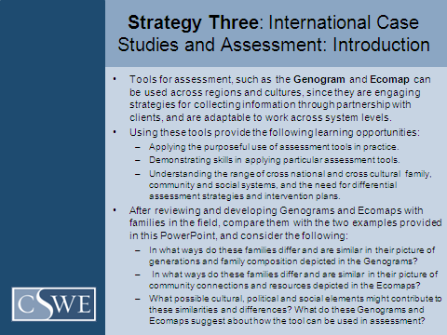

PowerPoint Slide 22: Overview of Genograms and Ecomaps as Assessment Tools
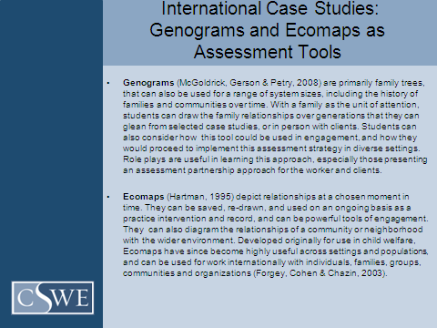
PowerPoint Slide 23: Overview of Case Example From Ho Chi Min City, Vietnam
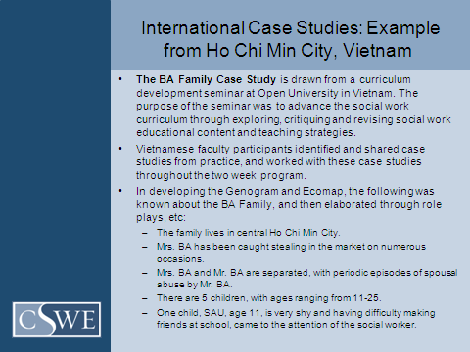

PowerPoint Slide 24: Genogram Example From Ho Chi Min City, Vietnam
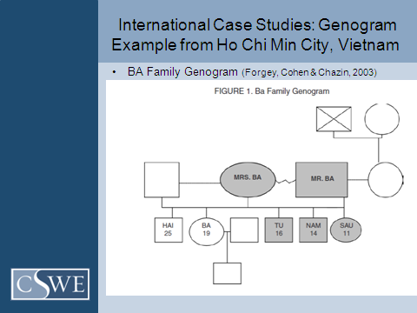
PowerPoint Slide 25: Ecomap Example From Ho Chi Min City, Vietnam
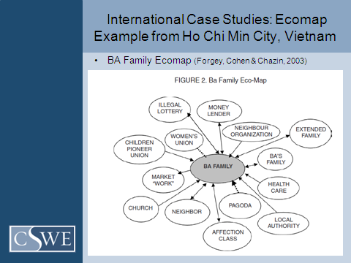

PowerPoint Slide 26: Overview of Example From New York City, United States
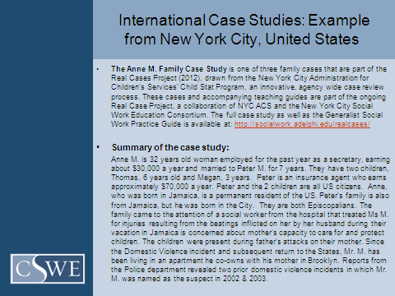
PowerPoint Slide 27: Genogram Example From New York City, United States
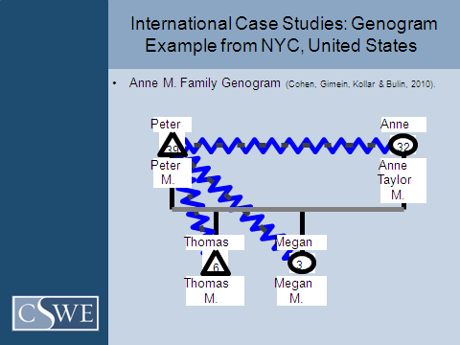

PowerPoint Slide 28: Ecomap Example From New York City, United States
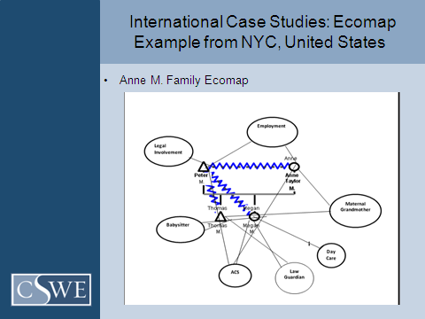
Resources and References (Slides 29 – 32)
This final section includes two slides that provide Web-based and professional literature that faculty members may find useful in adapting the teaching strategies in this guide, as well as in developing their own strategies. These slides are followed by two slides that include all references cited in the PowerPoint. The final slide has contact information for discussing the module and the Curriculum Integration Project further.
The websites included in Slide 29 are those already cited in the module and two CSWE centers (the Kendall Institute for International Social Work and the Center for Diversity and Social and Economic Justice) that have extensive resources for integrating international and cross-cultural perspectives.in the social work curriculum.

PowerPoint Slide 29: Resources for Developing Teaching Strategies for Generalist Social Work Practice: Websites
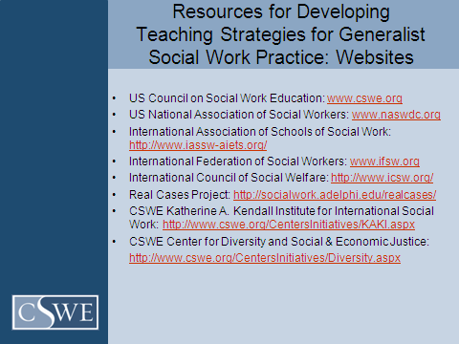
PowerPoint Slide 30: Resources for Developing Teaching Strategies for Generalist Social Work Practice; Professional Literature
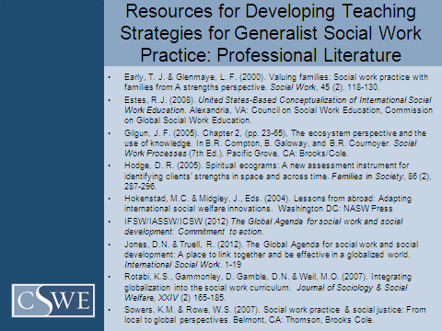
PowerPoint Slide 31: References of Citations in this PowerPoint
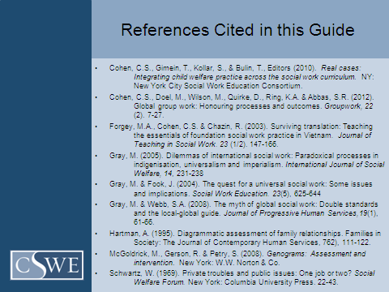
PowerPoint Slide 32: Thanks and Contact Information
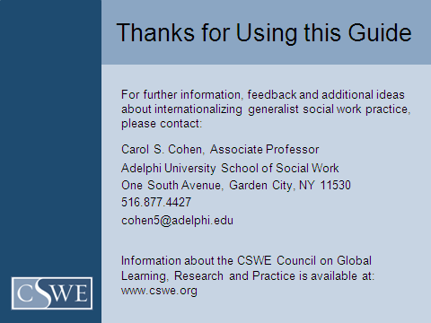

As noted in the final slide, I welcome hearing from faculty members who have any questions about the module or any comments that would contribute to internationalizing the teaching and learning in generalist social work practice. Please contact me with your feedback and to share your teaching innovations.
References
Cohen, C. S. (1995). Making it happen: From great idea to successful support group program. Social Work with Groups. 18(1). 67–80.
Cohen, C. S., Gimein, T., Kollar, S., & Bulin, T., Editors (2010). Real cases: Integrating child welfare practice across the social work curriculum. New York, NY: New York City Social Work Education Consortium. Fauri, D. P., Wernet, S.P., & Netting, F. E. (2007). Cases in macro social work practice (3rd ed.). Boston, MA: Pearson Allyn & Bacon.
Forgey, M. A., Cohen, C. S., & Chazin, R. (2003). Surviving translation: Teaching the essentials of foundation social work practice in Vietnam. Journal of Teaching in Social Work, 23(1/2), 147–166.
Haulotte, S.M. & Kretzschmar, J.A., Eds. (2001). Case scenarios for teaching
and learning social work practice. Alexandria, VA: Council on Social Work Education.
Hull, G. H. Jr., & Mokuau, N. (1994). Research in baccalaureate social work programs: A model for integration. Journal of Teaching in Social Work, 10(1/2), 137–147.
LeCroy, C. W. (1999). Case studies in social work practice (2nd ed.). Pacific Grove, CA: Brooks/Cole.
Reynolds, B. C. (1965). Learning and teaching in the practice of social work. New York, NY: Russell & Russell.
Richmond, M. (1961). The need of a training school in applied philanthropy. In R. E. Pumphrey & M. W. Pumphrey (Eds.), The heritage of American social work (pp. 287–291). New York, NY:Columbia University Press.
Rivas, R.F., Hull, G.H. Jr. (2000).Case studies in generalist practice, 2nd edition. Belmont, CA: Brooks/Cole.
Ross, J.W. & Wright, L. (2001). Participant-created case studies in multi-agency
training. Administration in Social Work. 25(1). 75-85.

Strom-Gottfried, K. (1998). Social work practice: Cases, activities and exercises. Thousand Oaks, CA: Pine Forge Press.
Towle, C. (1954). The learner in education for the professions. Chicago, IL: University of Chicago Press.
Wolfer, T. A., & Gray, K. A. (2007). Using the decision case method to teach legislative policy advocacy. Journal of Teaching in Social Work, 27(1/2), 37–59.
Wolfer, T. A., & Scales, T. L. (2006). Decision cases for advanced social work practice: Thinking like a social worker. Belmont, CA: Thomson Brooks/Cole.

