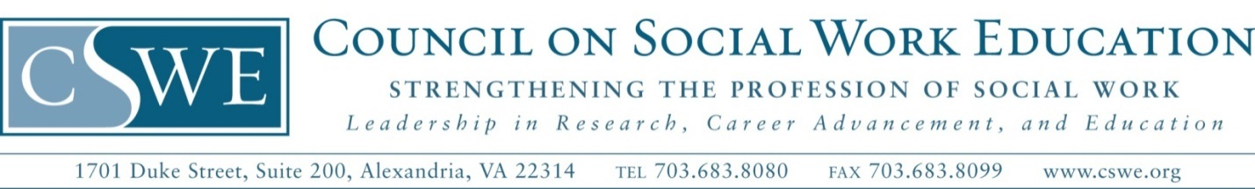

**Nonexclusive Permission to use Resources in the Policy Clearinghouse**

I hereby give the Council on Social Work Education (CSWE) and the Policy Coalition for Policy Education and Practice in Social Work (the Coalition) the nonexclusive right and permission to use and disseminate educational resources (e.g., course syllabi, course modules, film, media, assignments) in whole or in part, provided that I am given proper credit and attribution for its creation. My resource(s) titled,       .

I agree that I am the proprietor of this document. I agree that if I am not the sole proprietor of this document, I have given CSWE adequate and accurate information to obtain permission from all individuals who own the rights to this document. I agree that this document is original and that it does not contain any copyrighted material for which additional permission would be needed. I hereby verify that I own the right to give permission to use this material and have obtained the necessary permissions from any third parties involved.

I understand that CSWE or the Coalition may need to make minor changes to my document, including, but not limited to, spelling corrections, format adjustments, and the removal of phone numbers or email addresses, and I give my permission to CSWE or the Coalition to do so if necessary. I also understand that CSWE or the Coalition may add a logo or header to identify that the document is being distributed by CSWE or the Coalition.

I have read the foregoing and fully understand the contents thereof.

**Signature:**

**Name (Please Print):**

**Date:**

**Please provide the following information so that we may contact you if there are any questions:**

**Name:**

**Address Line 1:**

**Address Line 2:**

**City:**         **State:**         **Zip:**

**Email:**