**Gero-Ed Track Kick-Off Panel**

**Aging Your Way: Advancing Social Work Education and Practice**

Friday, October 24

11:00 a.m.–12:30 p.m.

Community-based initiatives have emerged in response to a growing desire to age in place. These initiatives are reshaping local communities, redefining how we age across the life course, and changing our care delivery systems. An expert panel explored this change and placed it within the broader context of social work education on aging services.

**Kick-Off Speakers**

**Stephen Golant** (moderator)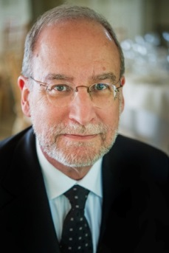

Stephen Golant, gerontologist and geographer, is a Professor in the Department of Geography at the University of Florida and a Fellow of the Gerontological Society of America. He was previously an Associate Professor in the Committee on Human Development and in the Department of Geography at the University of Chicago. He received his Ph.D. in social geography and social gerontology from the University of Washington and his B.A. and M.A. degrees in geography from the University of Toronto. Dr. Golant has researched and consulted on the housing, care, mobility, community, and transportation needs of the older adult population for most of his academic career. He has written or edited 125 papers and 7 books on these topics including *The Assisted Living Residence: A Vision for the Future (*The John Hopkins University Press, 2008). As a Fulbright Senior Scholar award recipient at the Gerontology Centre in Simon Fraser University, he investigated the need and prospects for assisted living residences in Canada.

**Emily A. Greenfield**(panelist)  
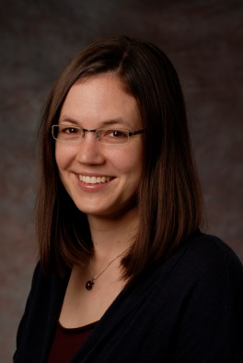

Emily Greenfield is an Associate Professor in the School of Social Work at Rutgers, the State University of New Jersey. She is also an affiliate of the Rutgers Institute for Health, Health Care Policy, and Aging Research. Dr. Greenfield’s research addresses how social relationships influence adults’ physical health and psychological well-being—for better and for worse. Her transdisciplinary scholarship focuses on both family and community relationships and contributes to research on several important social issues, including aging in place, intergenerational family relationships, and civic engagement in later life place. Her current projects examine community initiatives that aim to “re-weave” networks of social relationships among helping professionals, neighbors, and other stakeholders to support older adults in their own homes and communities. Dr. Greenfield’s research in this area addresses key questions facing innovative models in aging services, including what they are designed to do, the extent to which they achieve these objectives in practice, and how they can be sustained over time. As Faculty Coordinator for the Rutgers School of Social Work’s Programs on Aging, Dr. Greenfield also develops curriculum on geriatric social work and leads strategies to recruit students into work with older adults and caregivers.

**Amanda Lehning**(panelist)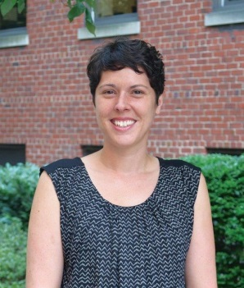

Amanda Lehning is an assistant professor at the University of Maryland-Baltimore, School of Social Work. She received an MSW from Bryn Mawr College, and her Ph.D. in Social Welfare from the University of California, Berkeley. After receiving her doctoral degree, she trained as an NIA-funded postdoctoral fellow at the University of Michigan, School of Social Work. She is also a Health and Aging Policy Fellow (2014-2015). Dr. Lehning’s research focuses on the effects of policies, programs, and neighborhood infrastructure on elder health, well-being, and the ability to age in place. She is particularly interested in community-level interventions that address the needs of older adults with limited financial and social resources. Her current projects include measuring aging-friendly community characteristics using existing data sources, a national survey of Villages and NORCs, two community-based programs that aim to help older adults remain in their homes and communities, and understanding the role of informal and formal support for helping low-income senior housing residents age in place.

**Nicole Ruggiano**(panelist)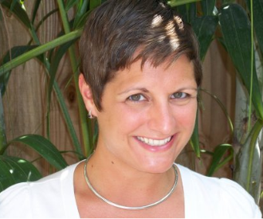

Nicole Ruggiano is an Assistant Professor within the School of Social Work at Florida International University. She is also a Hartford Geriatric Social Work Scholar (2011-2013). Dr. Ruggiano received her Ph.D. in Urban Affairs and Public Policy from the University of Delaware and her MSW from Temple University. Her research agenda focuses on health and home and community-based services for older adults with chronic conditions. She is currently investigating health self-management and self-direction among older adults with chronic illnesses and disabilities. She has published a number of articles on this topic, which advance current understandings of the role that older adults play within the health and disability support systems. In 2012, she was the recipient of Florida International University's Top Scholar Award for this research.