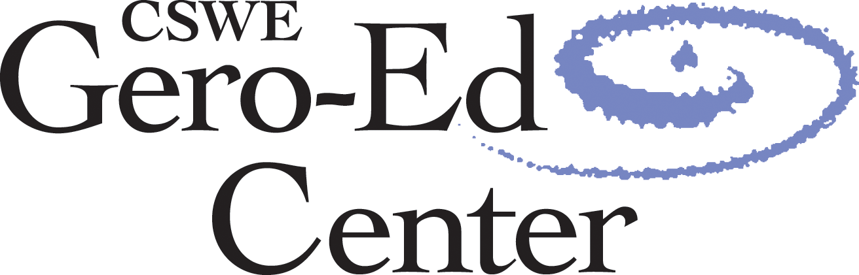

**2013 Gero-Ed Track: Challenges of Aging in a Global Society**

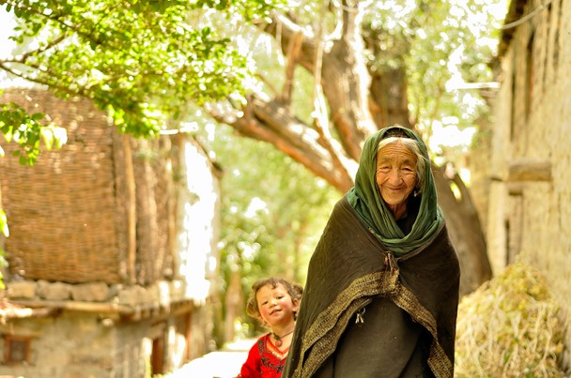

**PHOTO BY GOKUL KANAGARAJAH/WWW.GOKULPHOTOGRAPHY.COM**

**Join us for more than 30 aging-related education sessions addressing today’s most pressing issues in mental health, long-term care, workforce development, and more!**

**Signature Events**

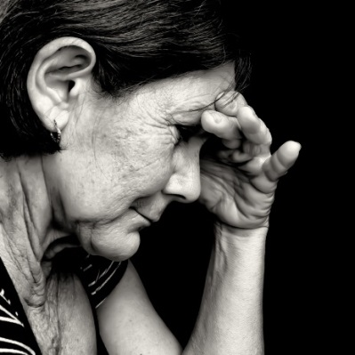**Gero-Ed Track Kick-Off Panel:**

**Trauma Across Generations: From Research to Practice**

**FRIDAY, NOVEMBER 1, 10:45 AM–12:15 PM, EMERALD**

The Kick-Off Panel highlights forensic social work with older adults, homelessness, older veterans, incarceration, and historical trauma. Learn how research informs practice with moderator Susan Green (University at Buffalo) and speakers Lori Daniels (Portland Vet Center), Tina Maschi (Fordham University), Sara Sanders (University of Iowa), Lori Thomas (University of North Carolina at Charlotte), and Karina Walters (University of Washington).

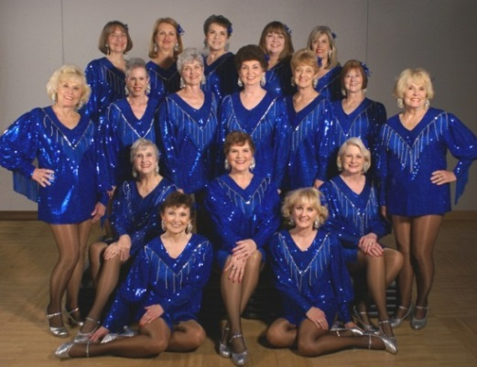

**AGESW Reception**

**FRIDAY, NOVEMBER 1, 7:00–8:30 PM, GRAND BALLROOM A/B**

The annual Association for Gerontology Education in Social Work (AGESW) reception is an opportunity to meet gerontology educators, researchers, and practitioners. *Don’t miss local senior talent The Dallas Tap Dazzlers’ electrifying performance!*

**Highlighted Sessions**

**Learn From a Gerontology Education Consultant**

**FRIDAY, NOVEMBER 1, 4:45–5:45 PM, MILAN**

Ask questions and get one-on-one support from social work faculty who have successfully gero-enriched their programs. Stop by this open forum and acquire effective strategies for infusing gerontology into your curriculum or creating a specialized gero structure (certificate, minor, concentration, etc.).

**Social Workers in the Aging Network: Workforce Implications  
SATURDAY, NOVEMBER 2, 10:45 AM–12:15 PM, CORONADO BALLROOM B**

In this accepted paper presentation, faculty and staff from the CSWE Gero-Ed Center, the National Resource Center on Participant-Directed Services (NRCPDS), and the National Association of Area Agencies on Aging (n4a) will discuss the outcomes of a survey of competency-based workforce initiatives and needs within the Aging Network.

**Student Competencies for the Aging Network: Strategies for Curriculum Development  
SATURDAY, NOVEMBER 2, 3:15–4:45 PM, PERIDOT**

This 90-minute interactive workshop, presented by the CSWE Gero-Ed Center, NRCPDS, and n4a faculty and staff, will focus on strategies to provide students with the competencies necessary for work in the Aging Network.

**Ashley Brooks-Danso Memorial Fund for Student Support**

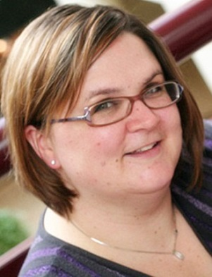**Congratulations to Todd Crawford who was awarded the 2013 Ashley Brooks-Danso Memorial Fund’s Student Travel Scholarship. He received $500 for travel expenses  
to CSWE’s Annual Program Meeting (APM) and a complimentary APM registration.**

**The Memorial Fund honors the legacy of Ashley Brooks-Danso (1979–2011), who  
co-directed the CSWE Gero-Ed Center from 2004 to 2008. She was a close friend, mentor, and colleague to many in the social work education community. Ashley  
was passionate about finding creative ways to recruit students to gerontological social work. All contributions to the fund directly support students with scholarship and stipend opportunities.**

**I would like to contribute to the Ashley Brooks-Danso Memorial Fund.**

Full Name: ___________________________________□ I would like the contribution to remain anonymous.

Address: _________________________________________________________________________________

□ I have attached a check made payable to the *Council on Social Work Education*.

□ Invoice me for $_________ at the address listed above.

□ Please charge $_________ to my (select one): MasterCard VISA American Express

Account number: ___________________________________ Exp. date: _________ Code: _______

Signature: ___________________________________

*The Council on Social Work Education is a charitable organization as defined by the IRS code 501(c)3 and your gift will be tax deductible to the fullest extent allowed by the law.*

**Visit the CSWE Gero-Ed Center online at** [**www.Gero-EdCenter.org**](http://www.Gero-EdCenter.org)

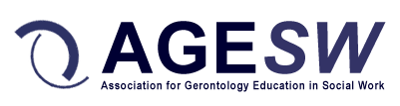 **Thank you to our partner:**