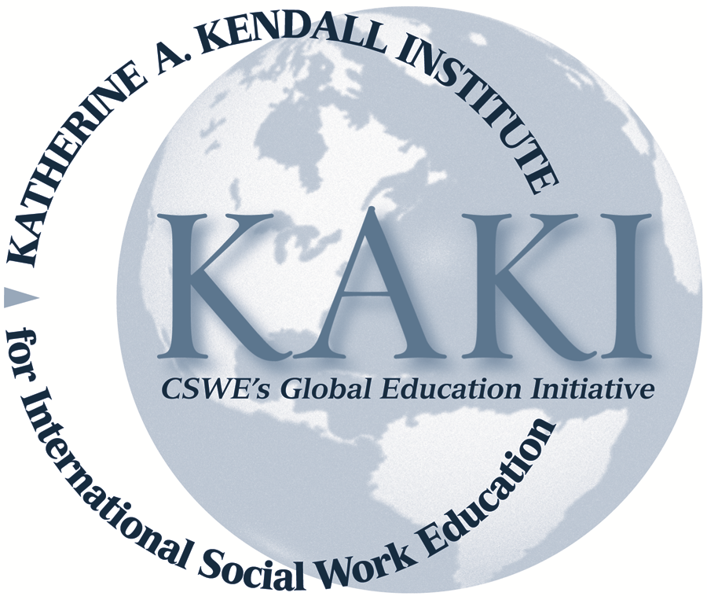
HUMAN RIGHTS AND SOCIAL WORK
A BRIEF BIBLIOGRAPHY

Amnesty International, www.amnesty.org
Useful website of a leading human rights NGO.

Clapham, A. (2007). Human rights: A very short introduction. New York, NY: Oxford University Press.

Coicaud, J. M., Doyle, M. W., & Gardner, A.-M. (2003). The globalization of human rights. Tokyo, Japan: United Nations University Press.

Healy, L. M. (2008). Exploring the history of social work as a human rights profession. International Social Work. 51, 735–748.

Healy, L. M. (2007). Universalism and relativism in social work ethics. International Social Work, 50(1), 11–26.

Healy, L. M., & Link, R. L. (Eds.). (2012). Handbook of international social work: Human rights, development, and the global profession. New York, NY: Oxford University Press.
See especially: Chapter 5: S. Staub-Bernasconi, Human rights and their relevance for social work as theory and practice; Chapter 66: J. Wronka, Overview of human rights: The UN conventions and machinery; Chapter 67: E. Reichert, Women and the human rights framework; Chapter 68: R. J. Link, Children’s rights; Chapter 69: G. Strand Hutchinson, Human rights of people with disabilities; Chapter 70: G. Bailey, Human rights and sexual orientation

Hertel, S., & Libal, K. (2011). Human rights in the United States: Beyond exceptionalism. Cambridge, UK: Cambridge University Press.

HKSAR Government. (2009). Report of the Hong Kong Special Administrative Region for the United Nations Human Rights Council universal periodic review. Retrieved from (http://www.legco.gov.hk/yr08-09/english/panels/ca/papers/ca0119cb2-650-1-e.pdf)

Hugman, R. (2008). Ethics in a world of difference. Ethics & Social Welfare, 2(2), 118-132.

Human Rights Watch, www.humanrightswatch.org
Good source of information on a wide range of global human rights issues.

Ife, J. (2008). Human rights and social work (Rev. ed.). Cambridge, UK: Cambridge University Press.

Inter-American Commission on Human Rights, www.cidh.oas.org

International Council of Social Welfare. (1969) Human rights and social welfare. Proceedings of the XIVth International Conference of Social Welfare. Helsinki, Finland, August 18–24, 1968. New York, NY: Columbia University Press.

International Federation of Social Workers. (2012). Human rights. Available at http://ifsw.org/policies/human-rights-policy/

International Federation of Social Workers (IFSW) with UNICEF. (2002). Social work and the rights of the child, a professional training manual on the UN Convention. Berne, Switzerland: IFSW.

Mishra, R. (2005). Social rights as human rights: Globalizing social protection. International Social Work, 48(1), 9–20.

Reichert, E. (2003). Social work and human rights. New York, NY: Columbia University Press.

Reichert, E. (Ed.). (2007). Challenges in human rights: A social work perspective. New York, NY: Columbia University Press.

Society for Community Organization. (2009). Submission to the Legislative Council Panel on Constitutional Affairs concerning the Report of the Hong Kong Special Administrative Region for the United Nations Human Rights Council universal periodic review. Available at
http://www.legco.gov.hk/yr08-09/english/panels/ca/papers/ca0119cb2-693-1-e.pdf

Staub-Bernasconi, S. (2011). Human rights and social work—philosophical and ethical reflections about a possible dialogue between East Asia and the West. Journal of Ethics and Social Welfare, 5, 331–347.

United Nations (UN). (1994). Human rights. Geneva, Switzerland: UN Centre for Human Rights.
A revised manual is underway and is available from www.ifsw.org

United Nations, Office of the High Commissioner for Human Rights, www.ohchr.org
This website is an excellent resource gem for both students and researchers. It contains the full text of all United Nations human rights instruments and updates on human rights issues. Of particular interest for research are the periodic country self-reports and treaty body assessments of compliance with the Convention on the Rights of the Child, the Convention on the Elimination of Discrimination Against Women, and other major treaties.

United Nations. (1998). Human rights today: A United Nations priority. New York, NY: United Nations Department of Public Information

United Nations, Department of Economic and Social Affairs. (2011). Current status of the social situation, wellbeing, participation in development and rights of older persons worldwide. [ST/ESA/339]. New York, NY: Author.

United Nations, General Assembly. (2011, July 22). Follow-up to the Second World Assembly on Ageing. Report of the Secretary-General. [A/66/173]. New York, NY: Author.

United Nations, Department of Economic and Social Affairs. (2008). Guide to the national implementation of the Madrid International Plan of Action on Ageing. New York, NY: Author.

UNESCO. (2011). Contemporary issues in human rights education. Paris, France: Author. Available at http://unesdoc.unesco.org/images/0021/002108/210895e.pdf

Wronka, J., & Staub-Bernasconi, S. (2012) Human rights. In K. Lyons, T. Hokenstad, M. Pawar, N. Huegler, & N. Hall (Eds.), The SAGE handbook of international social work (pp. 70–84). London, UK: SAGE.

Wronka, J. (2008). Human rights and social justice: Social action and service for the helping and health professions. Thousand Oaks, CA: SAGE.

Wronka, J. (1995). Human rights. In R. Edwards, (Ed.), Encyclopedia of social work (19th ed., pp. 1405–1418). Washington, DC: National Association of Social Workers.
A shorter version is in the 20th edition (2008).

Prepared by:
L. M. Healy
M. C. Hokenstad
C. K. Law
K. Libal
S. Zelenev

