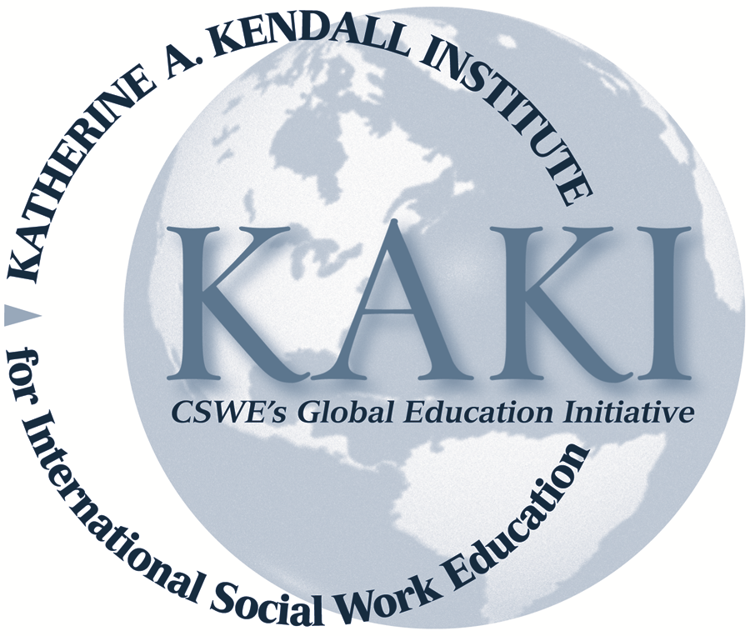

Katherine A. Kendall Timeline

1910 Katherine Anne Tuach (Kendall) born in Scotland (September 8)
1920 Emigrated to the United States
1933 Received BA from the University of Illinois
1939 Received Master’s degree from Louisiana State University
1945 Worked as Assistant Director of the Inter-American Unit and Training
Supervisor, International Service
1947 Began service at the United Nations
1948 First became acquainted with IASSW
1950 Published Training for Social Work: An International Survey at the UN
Receives PhD in social service administration from the University of
Chicago
Gave keynote speech at her first IASSW Congress in Paris, France
1954 Elected and served as Secretary of IASSW
1963 Became Executive Director at the Council on Social Work Education
(CSWE)
1971 Became full-time Secretary General of IASSW with a fully staffed office
1978 Katherine retires
2000 Published Social Work Education: Its Origins in Europe
2002 Published Council on Social Work Education: Its Antecedents and First
Twenty Years
2004 Founded the Katherine A. Kendall Institute for International Social Work
Education at CSWE
2008 Wrote booklet celebrating the 25th anniversary of UN Social Work Day
and the 60th anniversary of the UN Declaration of Human rights
2010 Katherine celebrated 100th birthday (September 8)
Katherine A. Kendall dies (December 1)

