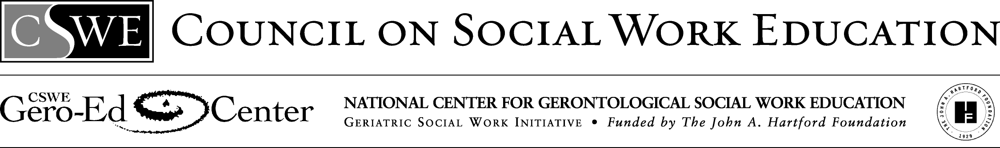

Multigenerational Family Dynamics: Case Study

This case study was developed by two MSW students at the University of Washington, for a generalist practice course on Multigenerational Relations and Social Justice. It could also be infused into generalist practice courses. The Advanced Gero Social Work Practice Guide (Curriculum Resource Examples) identifies this class exercise to support students’ attainment of the advanced gero practice behavior 2.1.3. Apply critical thinking to inform and communicate professional judgments.

Mom brought Grandma, a 75 year old African-American, into the doctor’s office, because Grandma has been experiencing increasing pain in her legs and hands over the last year. She was diagnosed with arthritis about 5 years ago, but has been reluctant to go back to the doctor for ongoing treatment. Grandma is caring for both her husband and her mother (Great-grandma), who also lives with them. Grandma’s husband (Grandpa, 80 years old) suffered a severe heart attack a year ago. Although he is still able to do many things for himself, he is becoming more disoriented and confused cognitively.

Great-grandma, 95 years old, moved in with Grandma and Grandpa over ten years ago. Increasingly frail, she needs Grandma, as her primary caregiver, to help with most of her Activities of Daily Living (ADLs). The doctor referred Grandma and Mom to talk with the social worker after prescribing her pain medicine for Grandma’s arthritis.

Mom, 53 years old, convinced Grandma to see the doctor after numerous tense discussions about Grandma needing help to manage her pain. Now Mom is voicing the opinion that Grandma cannot continue to care for Great-grandma in the home. Mom comes over to help Grandma with her caretaking responsibilities at least twice a week. But lately, Mom has needed to give more time, since Grandma is not able to meet the needs of both Great-grandma and Grandpa. Mom feels guilty that she’s not able to help as much as Grandma wants her to. However, Mom has just gone back to school to get a nursing degree, and works nights as a nursing aide in the hospital. Mom thinks Great-grandma needs to move to a skilled nursing facility, because no one in the family is able to provide for all her needs. Grandma is highly resistant to moving her mother to any kind of long-term care facility. Mom doesn’t like the idea either, but she does not know of any other option.

Mom’s son, 20 years old, is in college nearby, but is very busy and comes around only about once a month to help his mom. Mom’s brother, age 55, lives in another state and does not seem to understand or care about the difficulties that Mom is facing in trying to meet the needs of her parents’ and Great-grandma. The family is stressed, overwhelmed, near the breaking point and does not know how to resolve the issues facing them.

The social worker learns more about the family and as he listens, he draws the following genogram:

Gr-g’ma
95 yr
G’ma
75 yr
G’pa
80 yr
Bro.
55 yr
Mom
53 yr
Son
20 yr

If you were the social worker assigned to work with Mom and Grandma, how would you proceed to assess the family’s needs?

- What does the genogram tell you about this family?
- Who would you define to be the primary client? The secondary client? How do their needs differ?
- Who would you involve in assessment and care planning? What would be the primary areas that you would first assess?
- What would be the social work values reflected in your care plan for the family?
- How would you approach the different issues faced by family members across four generations and different life stages?
- What would you do to ensure that your assessment and interventions are culturally competent?
- What community resources could you identify to support this family?

