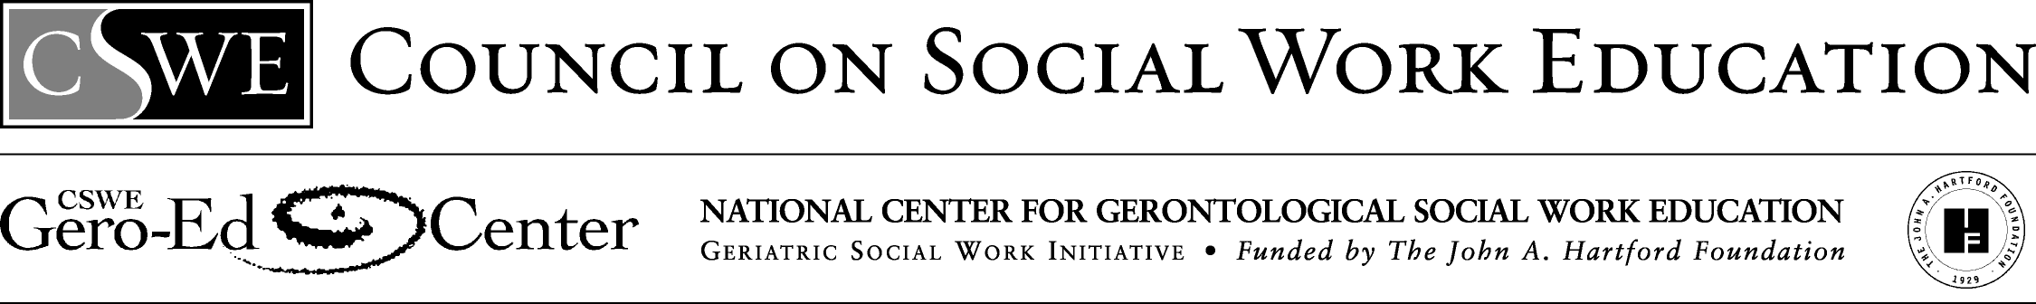
Communication with Older Clients: Communication Disorders Simulation
McMaster University

Note to Instructor:
This exercise could be modified to have one of the communicators be an older adult, the other a service provider. The Advanced Gero Social Work Practice Guide (Curriculum Resource Examples) identifies this in-class exercise to support students’ attainment of the advanced gero practice behavior 2.1.10(a)—Engage with individuals, families, groups, organizations, and communities.
This short classroom exercise is designed to increase students' awareness and empathy regarding communicating with people who have communication disorders. The class is divided into groups of 3 - one student is the person with the disorder, one is the communication partner with no disorder and one is observer (this role can be omitted if desired).

Each of the "persons with the disorder" is given a printed card. A message is written on each card as well as directions regarding how the person is to communicate. Three types of communication problems related to aphasia are incorporated into the exercise. During the next 2-3 minutes students with the disorder must try to convey their message to their communication partner who must, in turn, do his/her best to understand what is being communicated. Observers are asked to record the verbal and non-verbal behavior or both partners during this exchange.

Following this short exercise classroom, discussion can focus on the experience of each partner as well as the observations of the third person. The exercise generally promotes empathy for the experience of both partners as well as discussion around communication techniques.

YOU WANT TO INVITE THE OTHER PERSON BACKTO YOUR APARTMENT TO HAVE A COFFEE AND DISCUSS THE ASSIGNMENT AFTER CLASS.

YOU CAN ONLY MAKE VOWEL SOUNDS, NO CONSONANTS, AND NO GESTURES.
YOU WANT TO INVITE THE OTHER PERSON BACK TO YOUR APARTMENT AFTER CLASS TO HAVE A COFFEE AND DISCUSS THE ASSIGNMENT.

DUE TO A SPEECH/LANGUAGE PROBLEM (APHASIA), YOU ARE ONLY ABLE TO SAY "YES", "NO" AND "WELL. I'LL BEE" TO COMMUNICATE YOUR MESSAGE.
YOU WANT TO INVITE THE OTHER PERSON BACK TO YOUR APARTMENT AFTER CLASS TO HAVE A COFFEE AND DISCUSS THE ASSIGNMENT.

YOU HAVE APHASIA AND ALL YOUR NOUNS, ALTHOUGH "REAL" ENGLISH WORDS ARE USED INAPPROPRIATELY.

Reprinted with permission of the publisher. McMaster University School of Social Work. (1994). Communication and aging: A teaching resource kit. Hamilton, Ontario, Canada: Author.

