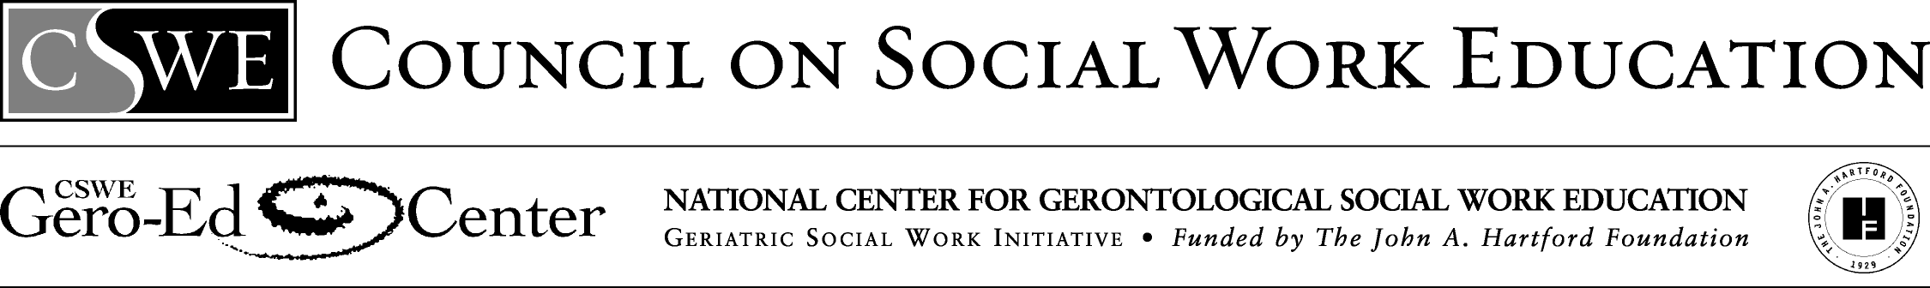

Older Adults in the Community or Organization: Macro Practice Assignment

Methods III, Social Work Practice with Large Systems
University of Wyoming, College of Health Sciences, Division of Social Work

The Advanced Gero Social Work Practice Guide (Curriculum Resource Examples) identifies this assignment can be used to measure student attainment of the advanced gero practice behavior 2.1.9—Respond to contexts that shape practice.
Older Adults in the Community or Organization: Assessment and Intervention Final Project
This project will have 6 parts, some of which will be turned in for a “draft” grade before all 6 parts are turned in together as the “final project.” The 6 parts of the project and their due dates and points are described below.

Part 1: Assess a community or organization using any of the assessment tools/methods covered in class or one that you find on your own. This assessment should be general and thorough, and also include a particular focus on older adult services, programs, and/or policies.
10 pts.; due 9-28-06

Part 2: Use at least 3 social work journal articles that pertain to a social issue/gap in service/improvement needed for the older adults in this community or older adults who are served by this organization that you assessed in part 1 to write a brief literature review that addresses your chosen issue.
10 points; due 10-12-06

Part 3: Develop a program/service that would benefit older adults in the community or organization you assessed.
10 points; due 10-26-06

Part 4: Choose a published evaluation tool or method, or develop your own tool or method, that would evaluate your proposed program’s effectiveness.
10 points; due 11-9-06

Part 5: Search grant databases to find a grant suitable for funding the program you developed in part 3. Use the format of the grant and insert your assessment, literature review, program idea and evaluation method in the appropriate sections of the grant.
10 points; 11-21-06

Part 6: Develop a one-page fact sheet/media release to hand out when you present your project to the class and to a “jury” of professional social workers in a 5 minute, creative presentation.
5 points; due 12-5 or 12-7-06

