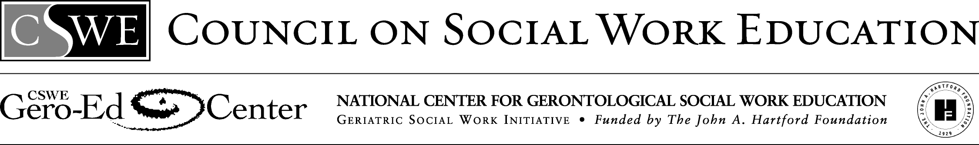

Ethnogeriatrics Group Assignment

For Infusion in Curriculum on Cultural Diversity
The Advanced Gero Social Work Practice Guide (Curriculum Resource Examples) identifies this comprehensive assignment to support students’ attainment of the advanced gero practice behavior 2.1.4—Engage diversity and difference in practice. It provides useful background information for both students and faculty.
San José State University, College of Social Work

Ethnogeriatrics

Ethnogeriatrics is the intersection of ethnicity, aging, and health and includes health care for older adults from diverse ethnic populations. This intersection is depicted below in Figure 1.

Ethnogeriatrics is concerned with the influence of cultural factors on geriatric care. Culture works to create differences in explanations of disease and treatment. "Western" biomedical health care has its own culture (e.g. knowledge, beliefs, skills, values), which is based upon scientific assumptions and processes, and that directly and indirectly influences definitions and explanations of disease.
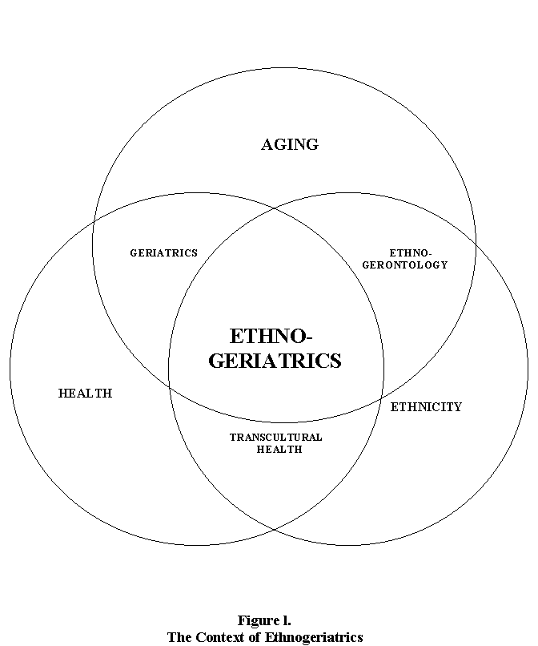

Older adults familiar with other health traditions may rely on factors such as nature, balance, and spiritual interventions to explain physical states, which differ from the “Western” biomedical culture. For example, people may identify conditions that do not match those found in biomedical references, yet these conditions can have a direct impact on health care, adherence to recommended treatment, and full communication between patient and provider. Culturally defined somatic disorders and culture-bound syndromes with their own beliefs about treatment may make the practice of culturally appropriate geriatrics complex. Additionally, contrasting values of independence versus community and family may result in conflicting expectations about the involvement of outsiders in providing care
Ethnocentrism, the tendency to view groups and cultures from the perspective of one’s own, may lead practitioners to misinterpret cross-cultural situations. Thus, ethnocentrism leads to miscommunication, which leads to stereotypes and disrespect, which lead to breakdown in delivery of culturally competent care. If practitioners lack experience working with individuals from a different culture, they may be likely to prejudge others based on stereotypes, hearsay, and emotions. These judgments may lead practitioners to slight an attribute of a person’s culture, either their language, beliefs, habits, or behavior, resulting in the patient taking offense and being less likely to adhere to treatment recommendations.
Group Assignment
This assignment places students in groups for the entirety of the semester. These groups can be considered task groups because they are formed for the purpose of achieving established goals and objectives. These groups will involve teamwork in pursuit of these goals and objectives. The learning mode utilized for this assignment is problem-based.

Problem-based Learning

In the problem-based learning paradigm, students identify, find, and use appropriate resources to solve complex, real-world problems. Problem-based learning is active, integrative and cumulative, and involves students working in groups until the assignment is completed.. Problem-based learning includes 5 iterative steps. (1) Students are presented with a problem. (2) They organize ideas and previous knowledge. (3) They pose questions, and define what they know and don’t know. (4) They direct resources and assign responsibility for answering questions. And, (5) they reconvene, explore newly learned information, and refine questions. A depiction of this learning process is in Figure 2, on the next page, and will be elaborated upon by your course instructor.

Solving Real World Issues – Your Group Project

What specific knowledge and skills does a social worker need to work with specific ethnogeriatric populations? How do you propose that social workers utilize this knowledge to develop and implement a health promotion program for this specific ethnogeriatric population? What will this specific ethnogeriatric health promotion program entail, and how and where will it be implemented?

Students will be divided into working groups to present a solution to these problems. The solution will be presented in two forms, (1) a group term paper with a section for individual reflection and (2) an educational in-class presentation on either May 2 or May 9. Classroom activities serve as a method to prepare students to develop a solution to these questions.

Start with a Story Start with the Concepts

Research Research

What concepts are involved? What story will you use?

Research the Problem

Ethnogeriatrics and social work
questions and plans to address them.

Research
(Outline and Drafts)

Teaching
(Presentation)

Final Paper

Adapted from Deborah Allen (Spring 2001)
Lecture given at the University of Washington

Figure 2
The Problem-based Learning Process

Working Groups

The students enrolled in this course will be divided into working groups of 4 to 6 students for the entirety of the semester. Group members will work together to identify the ethnogeriatric-related concerns and issues, identify potential solutions, and enact methods to investigate and research solutions. Together, group members will prepare the 2 outcomes of this process, (1) a group term paper with a section for individual reflection and (2) an educational in-class presentation on either May 2 or May 9.

Selecting Groups

In week 2 of this class, we will divide into working groups. The process used to select working groups will be determined as a class with guidance from the instructor. Each working group will research and present on a different ethnogeriatric group from the list on the next page:
African American/Black,

American Indian and Alaska Native,

Asian Indian (persons from India; the majority of Asian Indians practice the Hindu religion),

Chinese,

Filipino,

Hispanic/Latino/Mexicano (the diversity of the subgroups of Mexican American, Cuban American and Puerto Rican populations),

Japanese,

Korean,

Native Hawaiian/Pacific Islanders,
Pakistani,

Southeast Asian (Vietnamese, Cambodian, Hmong, and Laotian),

Or a working group may address another ethnogeriatric population if they can demonstrate that sufficient resources are accessible for the completion of this project.

The Group Paper (25 points) and The Individual Component (10 points)

Each group will be responsible for preparing a paper that responds to the questions presented in the solving real world issues section, which are: What specific knowledge and skills does a social worker need to work effectively with specific ethnogeriatric populations? How do you propose that social workers utilize this knowledge to develop and implement a health promotion program for this specific ethnogeriatric population? What will this specific ethnogeriatric health promotion program entail, and how and where will it be implemented?

These questions serve as a guide for essential content in the paper. Each group will formulate a plan to thoroughly respond to the questions. There will be some class time for discussion about how each group is doing, and there will be opportunities for groups to provide updates on their progress. Working groups can schedule consultation time with the course instructor.

Each working group member also has the responsibility of writing a 2- to 3-page personal reflection summary of her or his experience with the group. This personal reflection summary, worth 10 points, should identify the working group member’s (1) roles in the group, including those of leadership, (2) communication styles, (3) decision-making and conflict resolution strategies, and (4) overall evaluation of personal learning experiences and newly acquired insights into group processes and dynamics.

The Presentation (15 points)

Each working group will sign up for a presentation, on either May 2 or May 9. During this presentation each team will have the responsibility to (1) teach the class members the essential knowledge and skills that they have determined a social worker needs to work with their specific ethnogeriatric population of study, and (2) demonstrate how this knowledge will be used to develop and implement a health promotion program by (3) sharing the specific details of their proposed ethnogeriatric health promotion program including how and where will it be implemented?

The presentation should be fun and informative for class members and for working group members. Creativity is encouraged!

Resources

The Social Work Aging Resource Center (SWARC) web site at:

www.sjsu.edu/depts/SocialWork/swarc

The Stanford Geriatric Education Center, Ethnogeriatric Curriculum, on-line at:

http://www.stanford.edu/group/ethnoger/index.html
Glossary of Relevant Terms
Culture: The way of life of a population, including shared knowledge, beliefs, values, attitudes, rules of behavior, language, skills, and world view among members of a given society. It shapes human behavior because it is the foundation of conscious and unconscious beliefs about "proper" ways to live. Cultures change constantly. Different members of a society internalize and express different parts of their culture. Subcultures can also reflect differences by geographic region or other subgroups within a larger society (Andrews & Boyle, 1995; Henderson, 1990: Klein, 1995).
Cultural Competence in Geriatrics: Ability to give health care in ways that are acceptable and useful to elders because it is congruent with their cultural background and expectations. At the provider level, it has been described as including the demonstrated integration of:
A) awareness of one’s personal biases and their impact on professional behavior;
B) knowledge of
1) population-specific health-related cultural values, beliefs, and behaviors;
2) disease incidence, prevalence or mortality rates; and
3) population-specific treatment outcomes; and
C) skills in working with culturally diverse populations.
At the institutional level, it can be viewed as those systems of care that acknowledge the importance of culture, assess cross-cultural relations, are alert to cultural differences and their repercussions and adapt services to meet cultural needs. Health care settings may be placed on a continuum of cultural competence that have been described as including stages of: monocultural, nondiscriminatory, and multicultural; or destructiveness, incapacity, blindness, competence, and proficiency (Cross, Bazron, Dennis, & Isaacs, 1989; Foster, Jackson, Cross, Jackson, & Hardiman, 1988; Green & Leigh, 1989; Lavizzo-Mourey & Mackenzie, 1997, Tirado, 1998; Tripp-Reimer, 1999).
Cultural Guide or Cultural Broker: Consultants (health care, social service, senior service provider or respected leader) from the target ethnic population who can provide insight and information on health beliefs, culturally appropriate methods of showing respect to elders, and problem areas in health care interaction.
Emigration: Movement of individuals or groups OUT of the country or region of their original residence to settle in another area.
Ethnic Group: Originally defined by Gordon (1964) as a group of individuals with a shared sense of peoplehood based on race, religion, or national origin, it is now commonly used to refer to a group with a distinctive culture. Ethnicity is the active expression of culture. An ethnic group is a large group in which members self-identify. They internalize and share a heritage of, and commitment to, unique social characteristics, cultural symbols, and behavior patterns that are not fully understood or shared by outsiders (Barresi & Stull, 1993; Gelfand, 1993; Markides, Liang, & Jackson, 1990; Valle, 1998).
Ethnocentrism: The tendency to view groups and cultures from the perspective of one’s own.
Ethnogeriatrics: The intersection of ethnicity, aging, and health. Health care for elders from diverse ethnic populations.
Ethnogerontology: The study of the causes, processes, and consequences of race, national origin, culture, minority group status, and ethnic group status on individual and population aging in the three broad areas of biological, psychological, and social aging (Jackson, 1985).
Geriatrics: Health care for older adults.
Gerontology: The study of aging.
Immigration: Movement of individuals or groups INTO a country or region to settle there.
Minority: Subgroup within a population. In social science, it is used to identify a group that suffers subordination and discrimination within a society, usually because of their race, ethnicity or national origin. The term is used by the federal government to describe protected and/or disadvantaged ethnic or racial populations (Hooyman & Kiyak, 1999; Markides, 1993).
Race: Socially constructed categories based on parentage and physical appearance. Although the term is now considered by many anthropologists to be obsolete because of difficulty classifying populations with widespread genetic diversity, it continues to be widely used. The term is used in official government documents, such as in the U.S. Census, in which individuals identify their own racial identity. It sometimes serves as a basis for discrimination and demarcation in conflicts over social resources (Fried & Mehrotra, 1998; U.S. Census, 1990).
Spirituality: Can be defined as whomever or whatever provides someone a transcendent meaning in life. It may be expressed as a relationship with one god(s) or the creator, but can also refer to values such as: nature, energy force, belief in the goodness of all, or belief in the importance of family and community. Among some populations, it includes organized religion. It may or may not include belief in, and communication with, forces in the form of spirits (Puchalski, n.d).
Transcultural: A term used widely in social work and nursing to apply to people of diverse cultures. Transcultural social work is sometimes described as a body of humanistic and scientific knowledge with concomitant skills essential to help social workers care for people of diverse cultures (adapted from Leininger, 1997).

The Stanford Geriatric Education Center (SGEC) specializes in ethnogeriatrics. Figure 1 and the related text are adapted from the SGEC Ethnogeriatric Curriculum (http://www.stanford.edu/group/ethnoger/index.html).
For more information, go to the SGEC website (http://www.stanford.edu/group/ethnoger/index.html).

