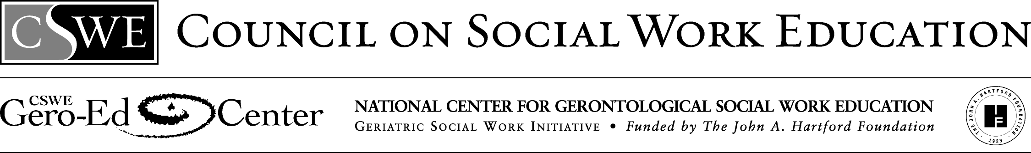

Infusion of Person-Centered and Participant-Directed Competencies:

Guidelines for Required Generalist Syllabi

Model infused required generalist syllabi are characterized by the embedding of person-centered (PC) and participant-directed (PD) knowledge, skills, and values throughout the *entire course* (e.g., course description, objectives, assignments, readings, and exercises, where appropriate), not just one class session.

Ideally, infused generalist syllabi meet the following criteria. Some of these relate specifically to PC/PD content, while other criteria, such as specification of goals and objectives, relate to quality syllabi generally. Use this list as an ideal toward which to strive over time:

* Language congruent with a PC/PD approach is used throughout the syllabus. This includes the use of the terms *participant* or *consumer* rather than *client*.
* The course description references PC/PD concepts, such as self-determination, consumer-directed care, independent living, strengths-based, and empowerment.
* Overall learning goals and objectives for the course are clearly stated.
  + Attention to PC/PD competencies are reflected in these overall course goals and objectives.
* Learning goals and objectives are articulated for each class session.
  + PC/PD issues are infused in these learning goals and objectives for at least 10% of the class sessions.
* PC/PD knowledge, values, and skill competencies are linked to EPAS core competencies and, where relevant, to the geriatric social work competencies (GSW Scale II).
* At least 10% of assigned readings address content on aging, persons with disabilities, and PC/PD approaches.
* Contemporary issues of aging and disability relevant to the required generalist area (Micro, Meso, Macro Practice; Human Behavior and the Social Environment; Policy; Research; Cultural Diversity; or practicum) are addressed.
* Social work values of social justice and commitment to historically underserved populations, including older adults and persons with disabilities, are reflected.
* Required assignments provide students with an option to address PC/PD issues and approaches.
* Experiential learning opportunities (e.g., role-play, small group exercises, and case studies) include examples of implementing PC/PD with older adults and persons with disabilities.
* Definitions of diversity incorporate age, ageism, older adults, ability, ableism, and persons with disabilities, along with other historically underserved populations.