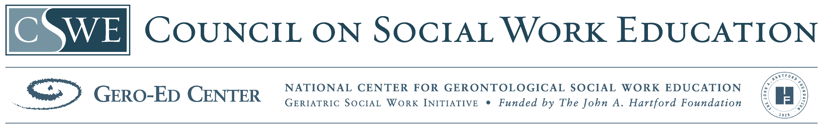
Older Adults and Family Therapy – Scripted Lecture and Course Materials
Slides 1-2 Title slides. Today we will be discussing family therapy with particular attention to multigenerational families and the issues for families that aging members present.
Slide 3 Slide 3 is a population description of multigenerational families and their elder members. One issue for the elderly are negative stereotyping which research finds to be untrue.
Slides 4-16 Slides 4 through 16 address assessment issues for families dealing with an elderly member. Assessment is believed to be best if it is multifaceted dealing with the physiological, psychological, social supports, spirituality, family functioning, caregiving, and other relationships. Additional issues for assessment include role reversal between adult child and elderly parent, conflicts and disagreements, spousal roles/relationships, and elder abuse. Finally assessment tools are presented to help the practitioner assess the above issues. The role of culture is important in assessing and measuring.
Slides 17-19 Slides 17 through 19 address the issue of evidence-based treatments and/or best practices for this population. Solution focused and psychoeducational approaches are recommended.
Slides 20-27 Slides 20 through 27 discuss treatment manuals. First websites are given for examples of treatment manuals for evidence-based practices with families with elders. Next an example of the steps of a typical first treatment session is given. Finally, a case example is used to illustrate the use of the intervention.
Slide 28 Slide 28 is an overall summary of the workshop.
Slides 29-34 Slides 29 through 34 provide a selection of internet resources.
Slides 35-38 Slides 35-38 are the references. These are also provided in a separate word document.

