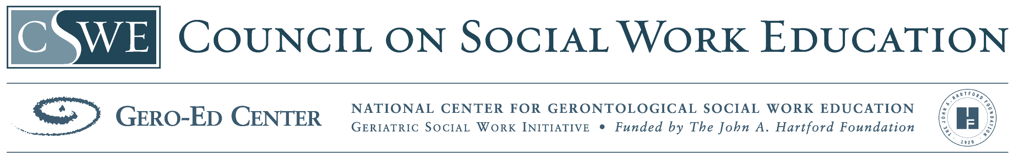
Substance Abuse Policy Module

School of Social Welfare
University at Albany

Overview

- Required Readings:
Patterson, T.L. & Jeste, D.V. (1999). The potential impact of the baby-boom generation on substance abuse among elderly persons. Psychiatric Services, 50, 1184-1188.

Schlaerth, K.R., Splawn, R.G., Ong, J. & Smith, S.D. (2004). Change in the pattern of illegal drug use in an inner city population over 50: An observational study. Journal of Addictive Diseases, 23, 95-107.

Committee on Aging of the Group for the Advancement of Psychiatry. (2005). Practical geriatrics: Medicare Managed Mental Health Care: A looming crisis. Psychiatric Services, 56, 795-797.

Deely, P.J., Kaufman, E., Yen, M.S., Jue, A., & Brown, E. (1979). The special problems and treatment of a group of elderly Chinese opiate addicts in New York City. British Journal of Addiction, 74, 403-409.

Suggested articles:
Substance Abuse and Mental Health Among Older Americans: The State of the Knowledge and Future Directions – www.samhsa.gov/OlderAdultsTAC/SA_M
H_%20AmongOlderAdultsfinal102105.pdf

New Generation Gap as Older Addicts Seek Help http://www.nytimes.com/2008/03/06/
us/06abuse.html?_r=1&oref=slogin

- Power Point Presentation including discussion questions and teaching points in notes section

The development of this module was made possible through a Gero Innovations Grant from the CSWE Gero-Ed Center’s Master’s Advanced Curriculum (MAC) Project and the John A. Hartford Foundation

