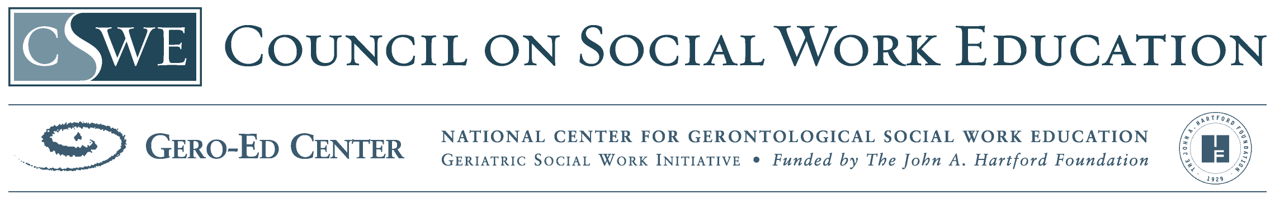
References Used in Module

American Psychiatric Association. (2000). Diagnostic and statistical manual of mental
disorders (4th ed., text rev.).
Bartels, S. J, Blow, F. C., Brockmann, L. M., & Van Citters, A. D. (2005). Substance Abuse and Mental Health Among Older Americans: The State of the Knowledge and Future Directions. Rockville, MD: Substance Abuse and Mental Health Services Administration.
Blow, F. C., & Barry, K. L. (2002). Use and misuse of alcohol among older women. Alcohol Research & Health, 26(4), 308-315.
Blow, F.C., Brower, K.J., Schuolenberg.J., Demo-Dananberg.L., Young. J., & Beresford, T. (1992). The Michigan Alcoholism Screening Test-Geriatric Version (MAST-g). A new elder specific screening Instrument. Alcohol: Clinical & Experimental Research, 16, 372.
Brennan, P. L., & Moos, R. H. (1996). Late-life drinking behavior: the influence of personal characteristics, life context, and treatment. Alcohol Health & Research World, 20(3), 197-204.
Brocato J.W.E.F. (2003) Harm reduction: A social work practice model and social justice agenda. Health and Social Work, 28(2), 117-125.
Center for Substance Abuse Treatment. (1998). Substance Abuse Among Older Adults. Treatment Improvement Protocol (TIP) Series, Number 26. DHHS Publication No. (SMA) 98-3179. Rockville, MD: Substance Abuse and Mental Health Services Administration.
Ewing, J. (1984). Detecting Alcoholism: the CAGE Questionnaire. Jama, 252(14), 1905-1907
Futterman, R. L., M. & Silverman, S. (2004). Integrating harm reduction and
abstinence-based substance abuse treatment in the public sector. Substance Abuse, 25(1), 3-7.
Gfroerer, J., Penne, M., Pemberton, M., & Folsom, R. (2003). Substance abuse treatment need among older adults in 2020: the impact of the aging baby-boom cohort. Drug and Alcohol Dependence, 69, 127-135.
Kadden, R.M. (2001). Behavioral and cognitive-behavioral treatment for alcohol:
Research opportunities. Addictive Behaviors, 26, 489-507
MacFarland, N., & Rockwood, A. (2004). 21st century approach to geriatric addictions. NASW NYS UPDATE, 29, 12 & 22.
Mason, S. E., & Sanders, G. R. (2004). Social work student attitudes on working with older clients. Journal of Gerontological Social Work, 42(3/4), 61-75.
Mayfied D., McLeod G., et al. (1974). “The CAGE Questionnaire: Validation of a New Alcoholism Instrument. “ American Journal Psychiatry, 131(10), 1121-1123.
NIAAA Social Work Curriculum for Alcohol Use Disorders. (2004, March). Module 10C, Older Adults and Alcohol Problems.
Oslin, D.W. (2004). Late-life alcoholism. American Journal Geriatric Psychiatry, 12(6),
571-583.
Oslin, D. W., Slaymaker, V., J., Blow, F. C., Owen, P. L., & Colleran, C. (2005). Treatment outcomes for alcohol dependence among middle-aged and older adults. Addictive Behaviors, 30, 1431-1436.
Blow, F., Bartels, S., Brockmann, L., & Citters, A. (n.d.) Evidence-Based Practices for Preventing Substance Abuse and Mental Health Problems in Older Adults. SAMHSA Older Americans Substance Abuse and Mental Health Technical Assistance Center
Saunders, J.B., Aasland, O.G., Babor, T.F., et al. (1993). Development of the Alcohol Use Disorders Identification Test (AUDIT): WHO Collaborative Project on Early Detection of Persons with Harmful Alcohol Consumption–II. Addiction, 88, 791–804.
Schultz, S.K., Arndt, S., & Liesveld, J. (2003). Locations of facilities with special programs for older substance abuse clients in the USA. International Journal of Geriatric Psychiatry, 18, 839-843.

