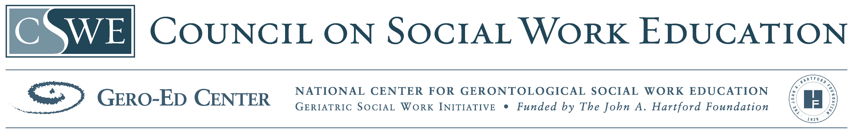
Substance Abuse in Older Adults

School of Social Welfare
University at Albany

Table of Contents

- Module Power Point

- Module Narrative for Instructors

  - Overview of geriatric addictions prevalence and demographics
  - Risk and protective factors
  - Barriers to Treatment
  - Co-Morbidity and the Older Adult
  - Age Matters
  - Screening Tools
  - Differentiating between Dependence, Abuse, and Onset of Addictions:
  - Treatment Interventions
  - Brief Protocols
  - Identification of levels of care
  - Ethnic sensitive practice
  - Film – Lecture by Fredrick Blow

- Materials for Students and Classroom Use

- Required Reading List and articles
- Suggested Resources for Further Learning
- Assessment tools
- Case presentation and questions

- Materials for Further Information

- Additional Resources - readings, videos, websites
- References for module
- Biography of Author

The development of this module was made possible through a Gero Innovations Grant from the CSWE Gero-Ed Center’s Master’s Advanced Curriculum (MAC) Project and the John A. Hartford Foundation

