**The Ashley Brooks-Danso Memorial Fund for Student Support**

*Ashley Brooks-Danso*

*June 1979–June 2011*

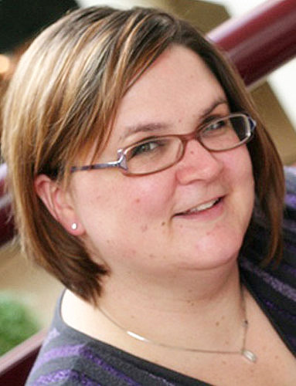The Ashley Brooks-Danso MemorialFund for Student Support will honor the life and legacy of Ashley Brooks-Danso, who died of a pulmonary embolism in June 2011, by supporting students with scholarship and stipend opportunities. She is survived by her loving husband of 7 years, Kofi, and her young daughter, Amelia Akua.

Ashley was a friend, mentor, and colleague to many, and she is deeply missed by all who had the benefit of knowing her. As her sister Liz noted, Ashley believed in the potential of all people and understood that amazing things happen when people take time to connect towards a larger purpose. For Ashley, part of that larger purpose was to enhance the quality of life for older adults and their families. Although her life was short in years, she left her mark on the field of gerontological social work.

From 2004–2008, Ashley ably and enthusiastically co-directed the CSWE National Center for Gerontological Social Work Education (Gero-Ed Center). Among her many accomplishments in that position, she started the Gero-Ed Track at CSWE's Annual Program Meeting (APM), developed the annual Gero-Ed Film Festival, and initiated the Anita Rosen student poster awards at APM. Ashley’s great passion at the Center was finding creative ways to recruit and support students to gerontological social work. Contributions to her Memorial Fund will be used to directly benefit students.

Ashley made a significant impact on the field of gerontological social work in the short time she was here. Join us in honoring her with a gift to the Ashley Brooks-Danso Memorial Fund for Student Support.

**I would like to make a contribution to the Ashley Brooks-Danso Memorial Fund for Student Support.**

Full Name: ___________________________________ I would like the contribution to remain anonymous.

Address: _________________________________________________________________________________

I have attached a check made payable to the *Council on Social Work Education*.

Please charge $_________ to my (select one): MasterCard VISA American Express

Account number: _______________________________________________ Exp. date: _________ Code: _______

Please invoice me for $_____ at the address listed above.

Signature: ___________________________________

*The Council on Social Work Education is a charitable organization as defined by the IRS code 501(c) 3 and your gift will be tax deductible to the fullest extent allowed by the law.*

*You may submit this form via e-mail to Gero-EdCenter@cswe.org or via postal mail to CSWE, Attn: Finance, 1701 Duke Street, Suite 200, Alexandria, VA 22314.*